ECA3101-NANO ELECTRONICS
Exp. 2. Simulation of Density of States of Quantum Well Structure using NanoHub
TEST CASE-1: Quantum Well
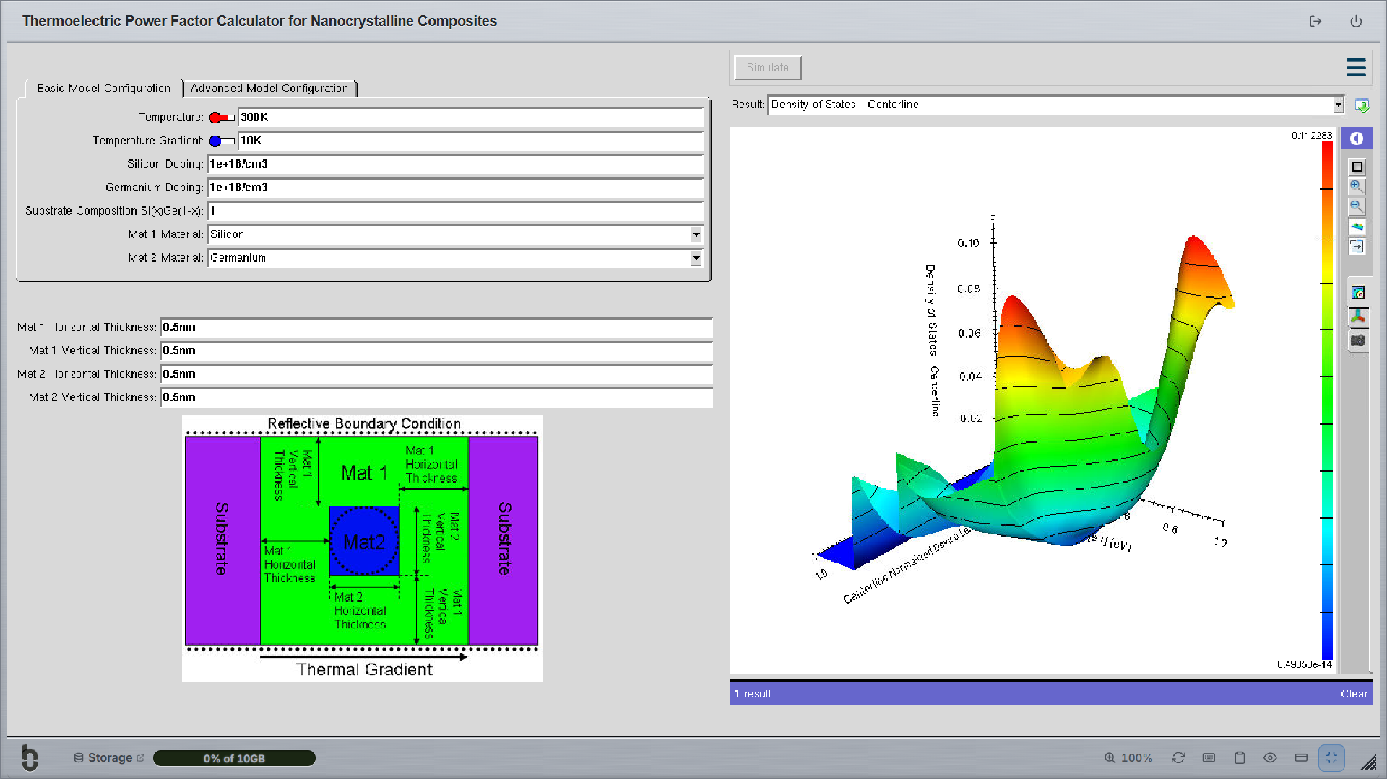
TEST CASE-2: Quantum Well


